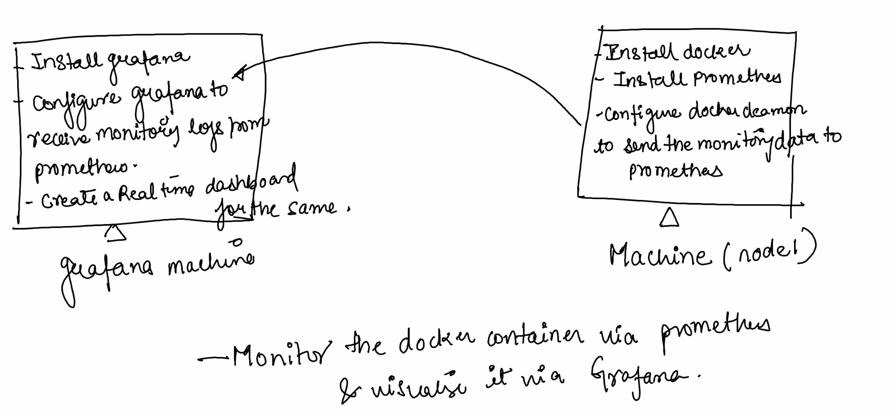

Prometheus : Monitoring tool

> Prometheus is a tool used to collect and store metrics from various systems.

->Metrics : These are like datapoints that machine records.

->Data collection: Prometheus collects these metrics from various machines. It's

like a central hub where all the machines send their information

-> Time series database : Prometheus stores this special type of database that keeps the track of changes over the time. its like a diary which records what happened and when.

Grafana : Visualisation tool

Grafana is used to visualise the metrics collected by prometheus. Think of it as an artist who takes the data from prometheus and creates a beautiful easy to understand pictures

1. Dashboard : These are collections of graphs and charts that show different metrics. It's like a big board where you can pin all your favourite data pictures.

2. Visualization: grafana can create different types of graphs like line charts , bar charts and pie charts to show the data.

3. Alerts: Grafana can also be setup to send the alerts if something unusual happens, like if the computer gets too hot.

Lab :

We will monitor the docker containers. Wherein the docker deamon will send regular updates to the prometheus ..prometheus will get this data and will send it to the grafana machine ….in grafana machine we will create the dashboard to monitor these resources.

<https://docs.google.com/document/d/1sGHKmL2fuFtwMmDPRfCGbx1kyGeLWGYV/edit?usp=sharing&ouid=103157204066713600014&rtpof=true&sd=true>